**12. ReactJS-HOL**

1. Set up project

|  |
| --- |
| npx create-react-app ticketbookingapp |

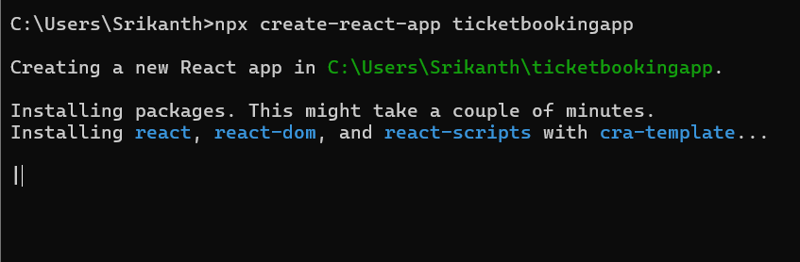

2.Update App.js

|  |
| --- |
| App.js  import React, { useState } from 'react';  function Greeting(props) {    const isLoggedIn = props.isLoggedIn;    if (isLoggedIn) {      return <h1>Welcome back</h1>;    }    return <h1>Please sign up.</h1>;  }  function LoginButton(props) {    return (      <button onClick={props.onClick}>        Login      </button>    );  }  function LogoutButton(props) {    return (      <button onClick={props.onClick}>        Logout      </button>    );  }  function App() {    const [isLoggedIn, setIsLoggedIn] = useState(false);    const handleLoginClick = () => setIsLoggedIn(true);    const handleLogoutClick = () => setIsLoggedIn(false);    return (      <div>        <Greeting isLoggedIn={isLoggedIn} />        {isLoggedIn ? (          <LogoutButton onClick={handleLogoutClick} />        ) : (          <LoginButton onClick={handleLoginClick} />        )}      </div>    );  }  export default App; |

**OUTPUT:**

